Image Processing and Computer Vision – The Dartboard Challenge

Subtask 1

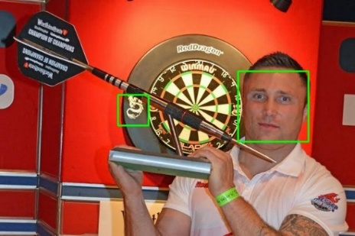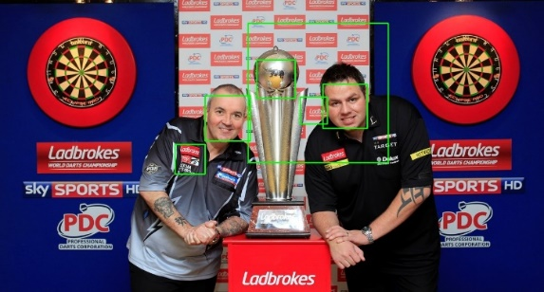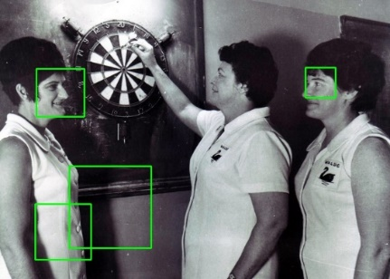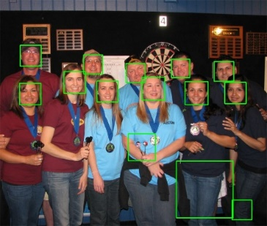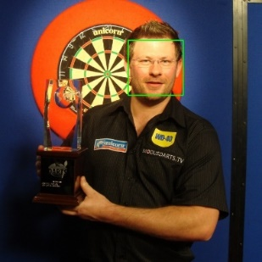The first subtask was to use the Viola-Jones object detector to find frontal human faces and to analyse its performance. To do this we first annotated the images by drawing rectangles around the faces present to generate our ground truth, then ran the provided face detection algorithm on the images which generated its own rectangles around what it detected as faces, these images are shown below.

Figures 1-5: The bounding boxes generated by the face detector.

We then edited the face.cpp file to compare the coordinates of our drawn rectangles and the code generated ones, by providing our coordinates in a csv file, this provided us the true positive rate for the algorithm which allowed us to calculate the F1 score. Our results are shown below.

|  |  |  |  |  |  |
| --- | --- | --- | --- | --- | --- |
|  | dart4.jpg | dart5.jpg | dart13.jpg | dart14.jpg | dart15.jpg |
| TPR | 1 | 1 | 1 | 1 | 1 |
| F1 Score | 1 | 0.88 | 0.667 | 0.5 | 0.667 |

The TPR results show that the face detection algorithm accurately identified all the faces which are in all of the images. However the F1 scores show that when the algorithm is run it falsely detected a number of objects as faces in all the images we tested it on other than dart4.jpg.

It can be difficult to accurately calculate the TPR as it can be hard to define what is a true positive, for example in image 15, none of the three faces are truly front facing, so it is hard to decide which are to be counted as faces and which are not.

Why is it always possible to achieve a TPR of 100%?

This is possible as you can write an algorithm which detects every part of an image to be a face, therefore it will correctly detect all of the faces as faces achieving a TPR of 100%. However it will also detect everything that is not a face, as a face.